1. **PURPOSE:** This SOP explains the necessary steps for proper dispersal and shipment of human tissue and blood samples in accordance with DOT/IATA regulations.
2. **SCOPE and RESPONSIBILITIES:**   
   1. Scope: The activities described in this SOP are to ensure safe handling, dispersal, and shipment of biohazardous material.
   2. Responsibilities:
      1. Principal Investigator
      2. Co-Principal Investigator
      3. Research Coordinator
      4. Program Coordinator
      5. Program Fellows
      6. Postdoctoral Researchers
      7. Graduate Students
      8. Undergraduate Students
      9. Administrative Support Staff
3. **DEFINITIONS and ABBREVIATIONS:**
   1. Definitions:

* Biohazard - a risk to human health or the environment arising from biological work, especially with microorganisms.
* Dry shipper – container, filled with liquid nitrogen, used to ship samples internationally.
* Hashcodes - used to identify sample without providing any patient information.
* Liquid nitrogen – nitrogen in a liquid state at an extremely low temperature used as a coolant.
  1. Abbreviations:
* DOT - Department of Transportation
* Hep B – Hepatitis B
* IATA – International Air Transport Association
* IRB – Institutional review board
* PHI – Protected health information
* PT – Procurement Team

1. **SAFETY AND QUALITY CONTROL:**
   1. Follow DOT/IATA shipping guidelines.
   2. Follow appropriate precautions based upon OSHA guidelines, infection control policies, and/or the institutional procedure manual for the handling of bodily fluids.
   3. The Hep B vaccine is optional but highly recommended when working with human tissue.
   4. Ensure all necessary containers are labeled with a biohazard sticker.
2. **MATERIALS, REAGENTS, and EQUIPMENT:**

Various materials, reagents, and equipment may be required for shipping samples. Generalized items may include, but are not limited to,

* Exam gloves
* Dry ice
* Liquid nitrogen
* Shipping label
* Dry shipper
* Box (cardboard or styrofoam)
* Specimen

1. **PROCEDURE:**
   1. To gain appropriate access to be a part of the Procurement Team, contact the Biorepository Program Coordinator.
   2. Request for specimens will typically be sent directly to Ken. Ken will match request with the current inventory.
   3. You will be given a list of hashcodes to pull from inventory. Use the most recent inventory spreadsheet to determine the location of the sample(s).
   4. As you pull samples place them in liquid nitrogen bucket.
   5. Domestic shipments:
      1. Place dry ice (rm MS518 – code 749518) in styrofoam box. Amount of dry ice should be measured in kg (needed for shipment info).
      2. Place vials of specimen in box.
      3. Tape the box ensuring it will not open during transport.
      4. Use scale to weigh box in pounds (needed for shipment info).
   6. International shipments:
      1. The Dry Shipper without liquid nitrogen weights 12 lbs. Before you start filling the Dry Shipper with liquid nitrogen make sure it is indeed 12 lbs.
      2. Take the nozzle from the liquid nitrogen tank and place it inside of the Dry Shipper. In increments, start filling the Dry Shipper.
      3. The cryocane holding cylinder inside of the Dry Shipper will be your indicator of the liquid nitrogen level. Once the level is about half way or higher, stop and let the liquid nitrogen absorb into the Dry Shipper.
      4. After the liquid nitrogen has fully been absorb, weigh the Dry Shipper. Continue this process until the Dry Shipper reaches ~19.5 lbs.
      5. Next, begin to fill the cryocanes with tubes. Each cryocane is design to hold 5 tubes (Appendix Fig. 7.1)
      6. Load the cryocanes inside of the cylinder inside of the Dry Shipper (Appendix Fig. 7.2)
      7. Close the Dry Shipper and wire tie it.
      8. Place the Dry Shipper inside of the shipping box. The box must have labels. The labels that are required are: directional labels pointing up, exempt human specimen labels (at least 2), fragile label, handle with care label, and labels on top that states “Dry Shipper non-hazardous.” Before shipping, box should look like (Appendix Fig. 7.3).
   7. Email Andrew Hernandez ([andrew.hernandez@uky.edu](mailto:andrew.hernandez@uky.edu)) with shipment information to include:

* First and last name of receiver
* Business name (if applicable)
* Full address
* Phone number
* Weight of package in pounds
* Amount of dry ice in kg, if domestic
* Contents of package with amount of specimen, if international
* Account information or payment information of receiver as well as shipment type preferred e.g., priority overnight, first overnight, 2-day express saver (if applicable)
  1. If Andrew is not here send information to Allison Walters ([allison.walters1@uky.edu](mailto:allison.walters1@uky.edu)).
  2. Give shipping container to Andrew or Allison.
  3. Remove all samples pulled from inventory. If you are not authorized to edit inventory send list to Mindy Thompson ([msthom9@uky.edu](mailto:msthom9@uky.edu)).

1. **APPENDIX**

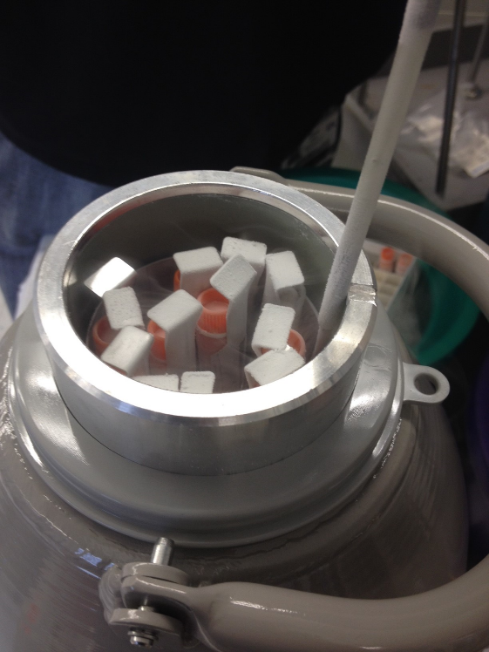

7.1

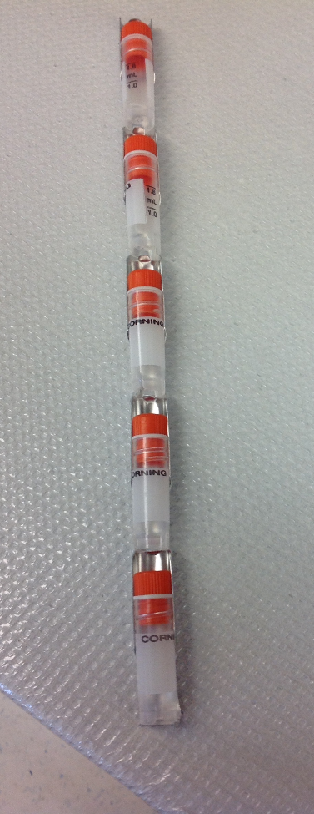

7.2

Example shipping forms

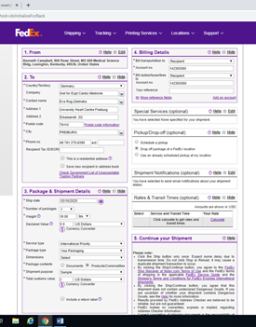

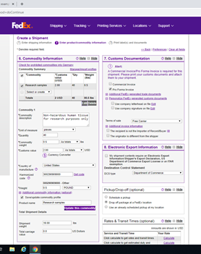

* Print out Shipping forms
* Insert in plastic envelope
* Attach envelope to Shipper
* Place outside MS508 if scheduled pickup, or next to FedEx pickup location in basement of building